Name : Saurabh Sanjay Jadhav

Topic : VPC endpoint.

Assignment no. : 19

1. Create VPC network.

Name : webapp-vpc

IPv4 CIDR : 10.0.0.0/24

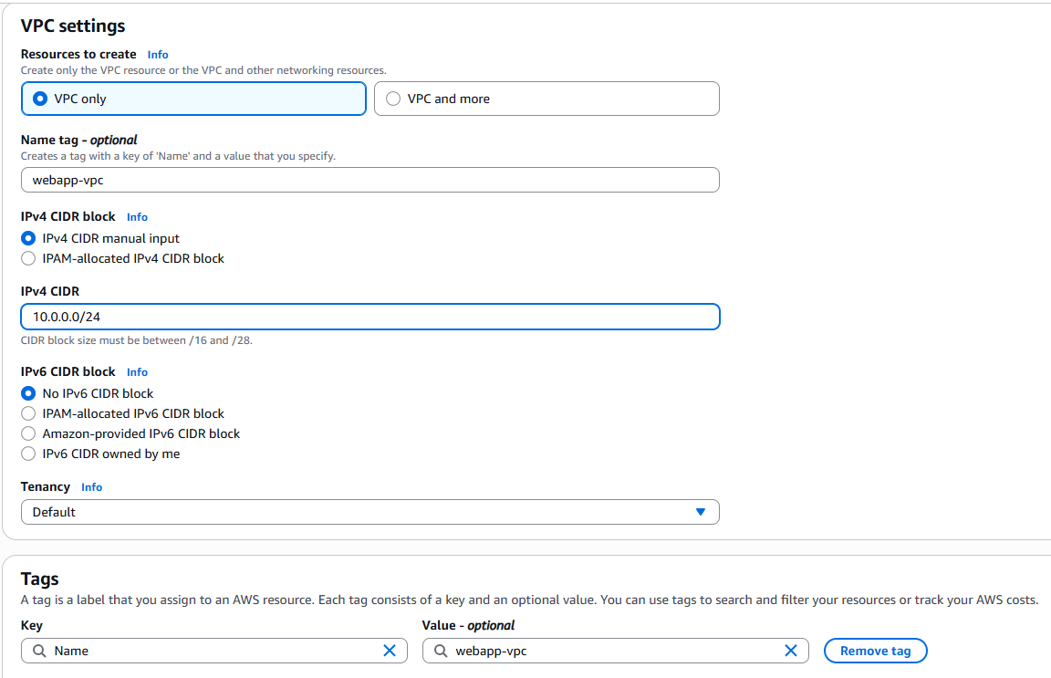

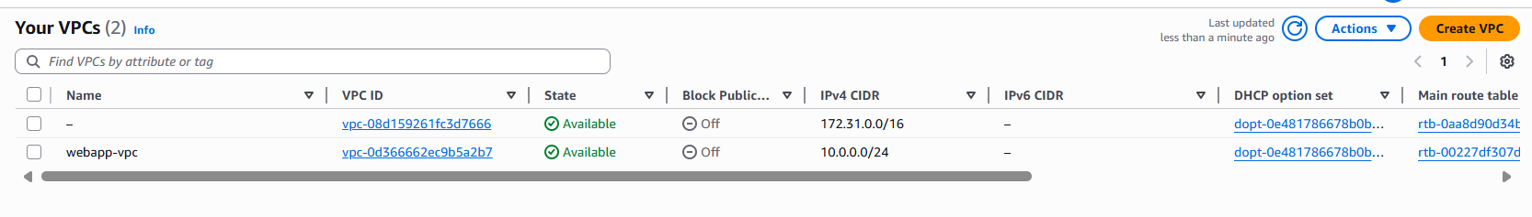

1. Create 2 subnets pubic and private in vpc.

Public subnet CIDR : 10.0.0.0/25

Private subnet CIDR : 10.0.0.128/25

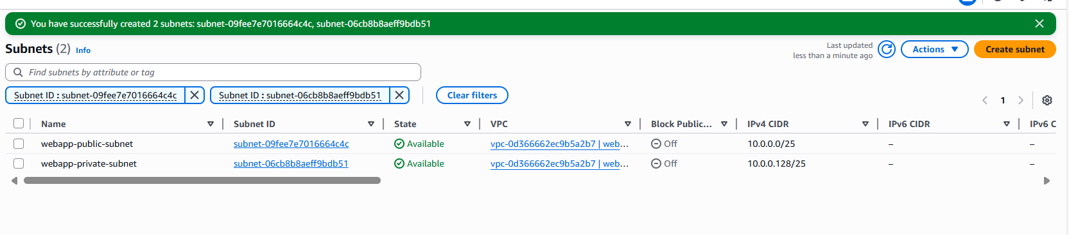

1. Create two EC2 instances.
2. In public subnet:

Name : webapp-server

In network config select vpc, select public subnet, create security group with public access and enable auto-assign public IP

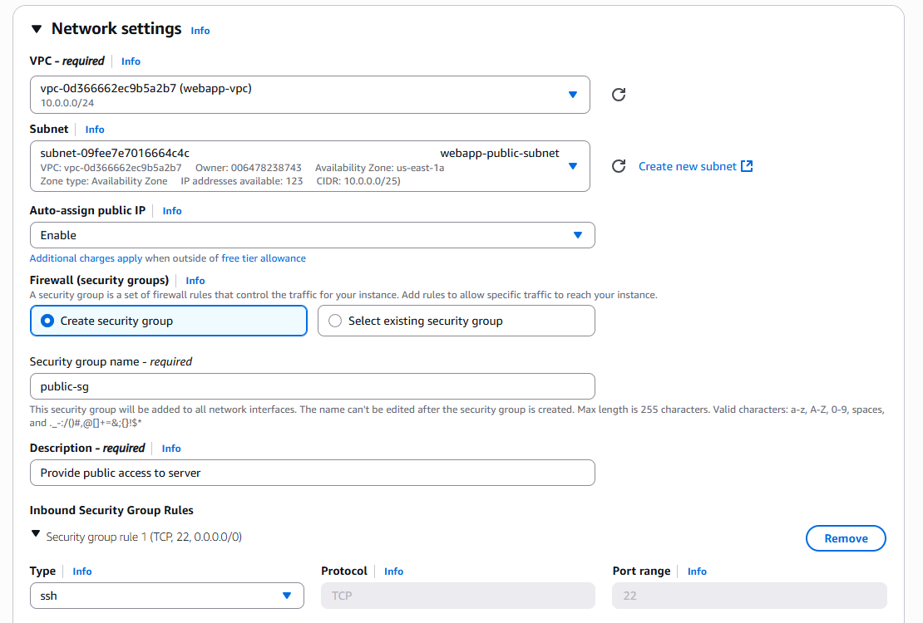

1. In private subnet:

Name: database-server

In the network settings select the webapp-vpc, select private subnet and assign security with access to MYSQL request.

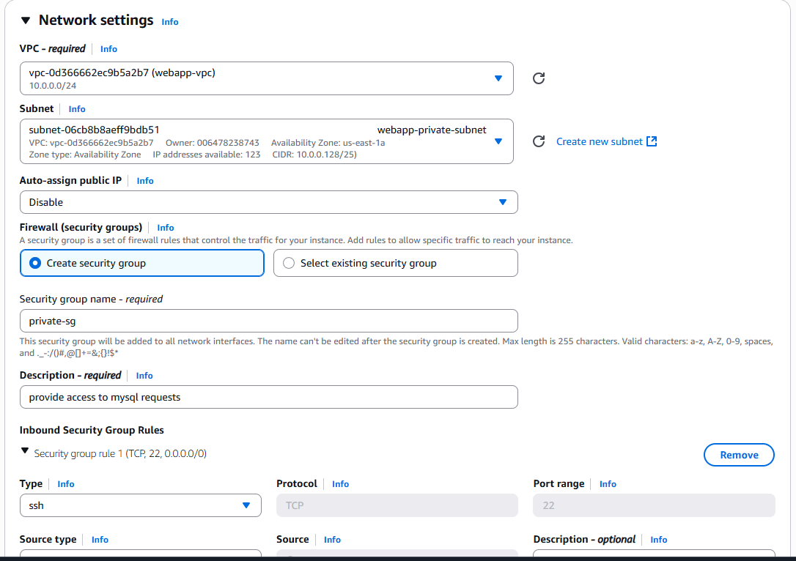

1. Create internet gateway and attach it to webapp-vpc.

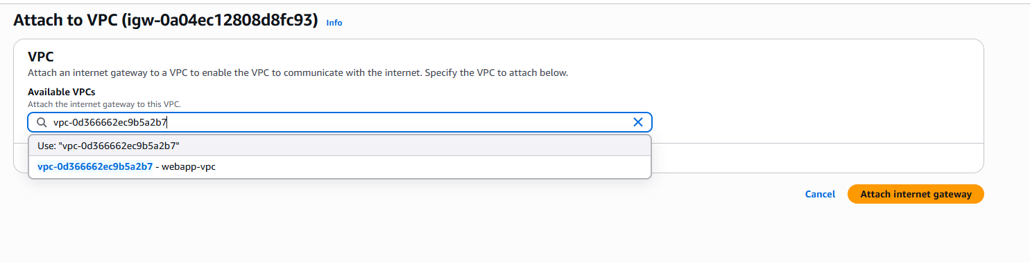

1. Create route table for public-subnet to internetgateway.

Associate the public subnet to route table.

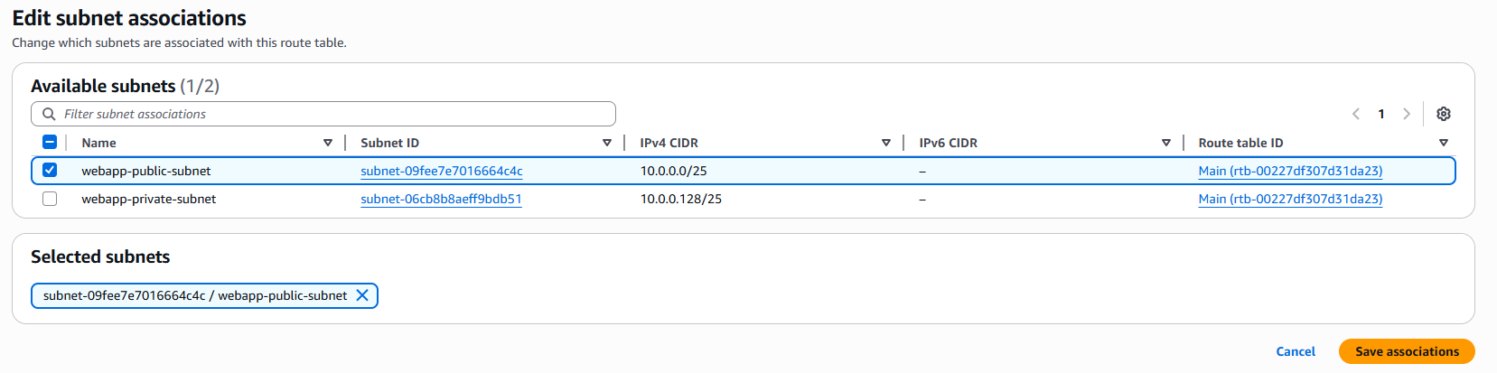

Add route to Internet gateway.

1. Able to connect to webapp-server.

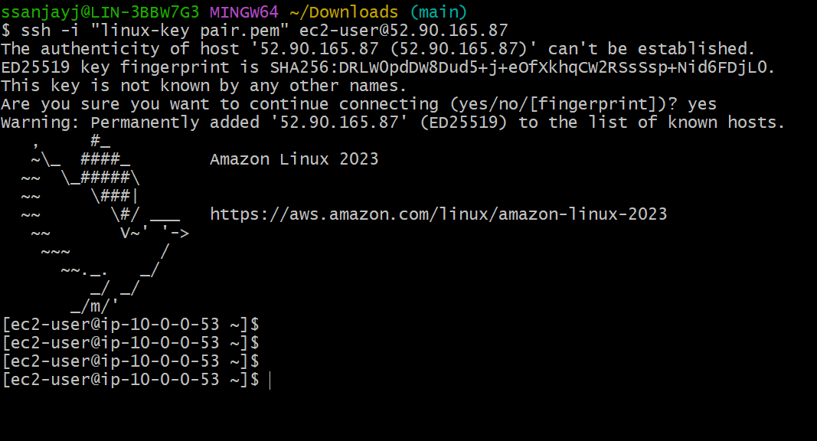

1. Try to connect to database-server in private subnet.
2. Copy the key-pair file from local to webapp-sever(in public subnet)

scp -i "linux-key pair.pem" "linux-key pair.pem" ec2-user@52.90.165.87:~/



1. Change the file permission for key-pair file.

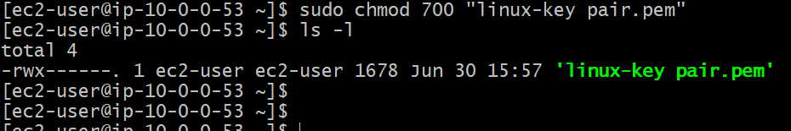

1. Able to connect to database-server.

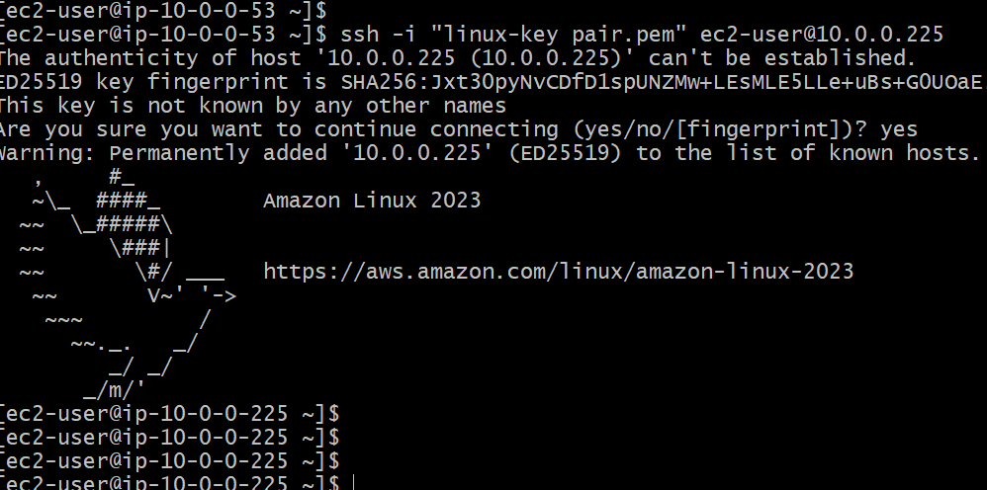

1. But unable to access internet or install package.

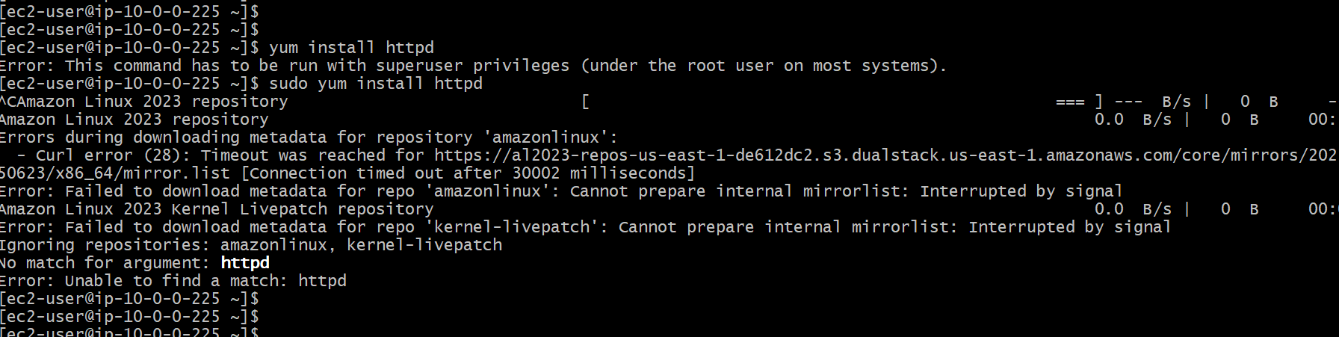

1. Create access key for aws configure login

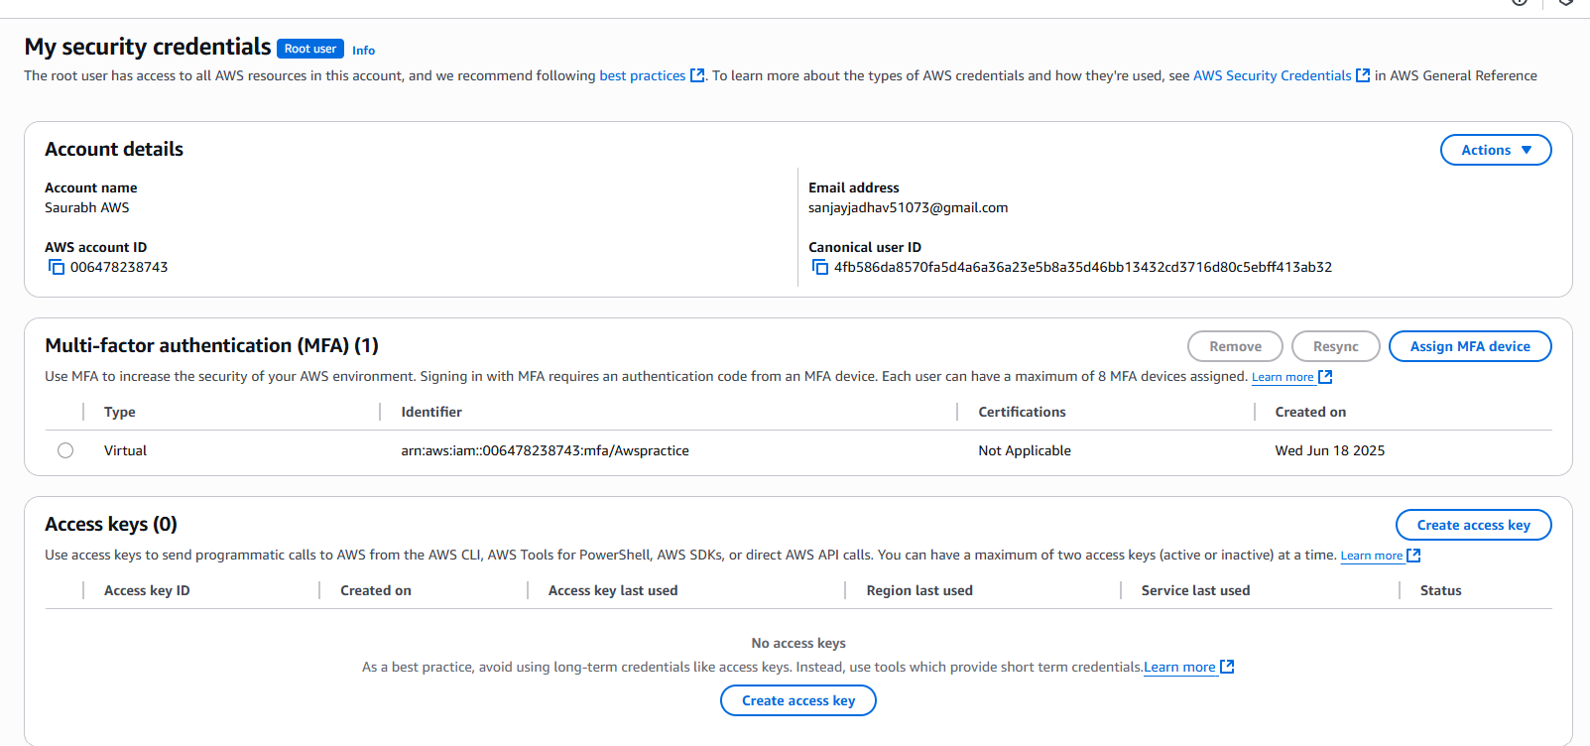

1. We have credentials but could not connect to s3 endpoint.

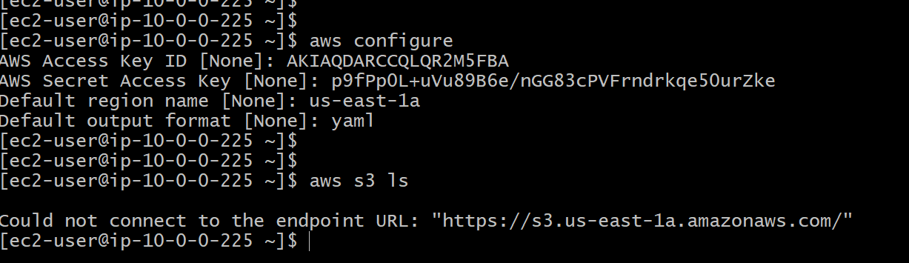

1. Create endpoint.

Name: webapp-s3-endpoint

Type: AWS service

Select the service : s3

Network : webapp-vpc

Route table: webapp-publicsubnet-to-IGW

1. Finally we are able to create, list and remove s3 bucket using database server.

